Stella Fu & James Aeron Susbilla

Emerging Technologies And Applications

Report

Contents

**1. Introduction** 2

**2. Methodology** 2

**2.1 Data Gathering** 2

**2.2 Data Analysis** 3

**3. Discussion** 6

**4. Outcome** 38

**5. Project Management** 44

**6. Conclusion** 44

**7. References** 46

# **1. Introduction**

This report discusses our development process of a tool/guide that will be used by organizations for investigating emergent technology solutions that can address specific deficiencies within their business operation. With the use of this tool, organizations can input any specific scenario they are having a problem with and then get a response of a list of emergent technology solutions that can address that problem. The report will be structured by first introducing the methodology we used regarding the gathering and analysis of data and then discussing the outcome of the analysis and lastly outlining each project task meeting we have had throughout this project.

# **2. Methodology**

This section will discuss how we have gathered data which will be used for analysis. It will also discuss our approach in analysing the gathered data as such will be the most crucial component in the tool development, since the effectiveness of the tool will be highly dependent on the accuracy of the analysis.

## **2.1 Data Gathering**

All sources used in the information gathering process were all secondary sources as such the list of sources are outlined below.

|  |  |
| --- | --- |
| Source Name | Source Link |
| Successful AI Examples in Higher Education That Can Inspire Our Future | https://edtechmagazine.com/higher/article/2020/01/successful-ai-examples-higher-education-can-inspire-our-future |
| Top 10 IoT applications in 2020 | https://iot-analytics.com/top-10-iot-applications-in-2020/ |
| Gartner Top 10 Strategic Technology Trends for 2020 | https://www.gartner.com/smarterwithgartner/gartner-top-10-strategic-technology-trends-for-2020 |
| Gartner Top 10 Strategic Technology Trends for 2018 | https://www.gartner.com/smarterwithgartner/gartner-top-10-strategic-technology-trends-for-2018/ |
| Gartner Top 10 Strategic Technology Trends for 2019 | https://www.gartner.com/smarterwithgartner/gartner-top-10-strategic-technology-trends-for-2019/ |
| Accenture Technology Vision 2020 Full Report | https://www.accenture.com/us-en/insights/technology/_acnmedia/Thought-Leadership-Assets/PDF-2/Accenture-Technology-Vision-2020-Full-Report.pdf |
| Predictable Influence of IoT (Internet of Things) in the Higher Education | https://www.researchgate.net/publication/315599751_Predictable_Influence_of_IoT_Internet_of_things_in_the_Higher_Education |
| 2020 TTR Public release final | https://www.nato.int/nato_static_fl2014/assets/pdf/2020/4/pdf/190422-ST_Tech_Trends_Report_2020-2040.pdf |

Figure 2.1.1 The list of sources

Six of the resources were provided by the course tutor and the other two were discovered due to how we felt that there were insufficient cases examples of technologies in the provided resources, being use in a real-world situation, such resources were found by searching emerging technologies online (see data sources table). These sources were selected because of how these articles were recent which meant emerging technologies that are currently being implemented in real world entities can be used to replicate those emerging technologies to potential organisations which will use the developed tool.

## **2.2 Data Analysis**

Thematic Analysis is a qualitative method that we used in conducting data analysis. Such method begins with defining colour codes to be used when identifying either a fact, solution, real-world applications, and gaps of emerging technologies.

* solutions - green
* facts - yellow
* application - blue
* limitation – red

Once codes are defined, we then carefully read each resource and highlighted the facts, solutions, applications, and gaps of emerging technologies.

|  |  |
| --- | --- |
| Gaps |  |
| Facts |  |

Figure 2.2.1 Examples of colour coding in the article *Predictable Influence of IoT (Internet of Things) in the Higher Education*

Once done reading the resources, we then created a shared spreadsheet template for analysis such outlines the fields of Resource Name, Unit of Information, Extracted Information, our Interpretation of the text extracted, Technology, Application, Cases/Example, Type of Discovery (gaps, facts etc) and Information from Other Sources.

Figure 2.2.2 Example of shared spreadsheet template for analysis

Once template was created, we then copied each highlighted text data into the template and started generating emerging technology themes and its applications which represents the extracted data. During this phase, we also read through each other extracted information and see if we both agree with each other’s generated technology and application themes.

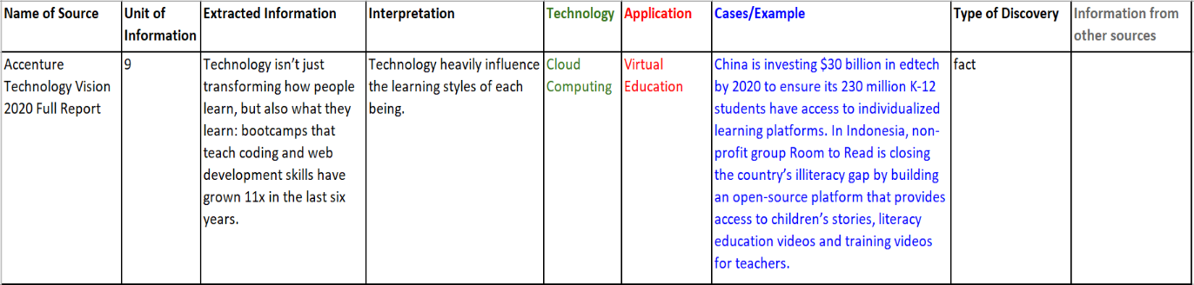Figure 2.2.3 Example of extracted data from Accenture Technology Vision 2020 Full Report

Once themes were generated, we then further reviewed each and generated a table of emerging technologies with its applications. After that, we proceeded to creating a sub-spreadsheet for each theme and then placed related data to each emerging technology theme.

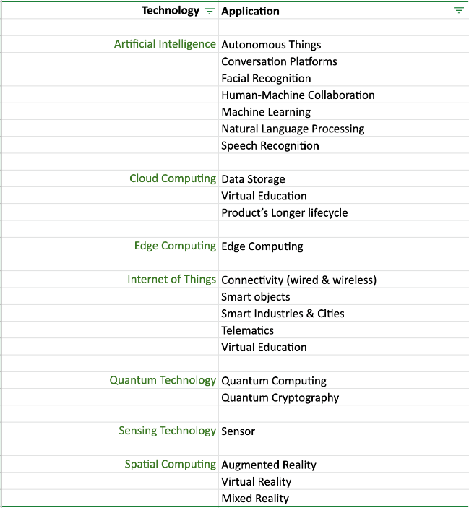

Figure 2.2.4 Table of emerging technologies with its applications

# **3. Discussion**

This section discusses our data analysis. Seven themes emerged from the analysis. These themes are emerging technologies that small-medium size enterprises could apply to address specific gaps in their organisations. They are Artificial Intelligence (AI), Cloud Computing, Edge Computing, Internet of Things (IoT), Quantum Technology, Sensing Technology and Spatial Computing. Also, every technology has its own applications (refer to Figure 2.2.4).

During data analysis, we only captured sentences or paragraphs related to technologies that could be potentially used by small-medium enterprises. Therefore, technologies like satellite technology and technologies that used for military purposes were not in our scope.

The technology themes were generated from the raw data by using the original terms mentioned in the data. Here is an example about how we directly generated “Artificial Technology (AI)” from the raw data (refer to Figure 3.1).

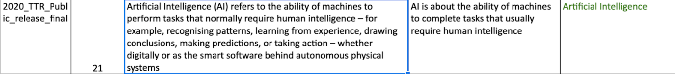Figure 3.1 Generating the Theme: AI from Raw Data

If the data did not clearly mention the name of the technology, we searched for possible answers online. For example, sensors are an important hardware to enable the Internet of Things (IoT) and AI, and they were mentioned frequently in our data. Eventually, we classified sensors into an independent technology theme: Sensing Technology rather than include it into IoT or AI.

We also used the search engine to decide if certain technologies could be grouped under the same technology theme. For example, we found a certain degree of similarity among three technologies: Augmented Reality (AR), Virtual Reality (VR) and Mixed Reality (MR), so we used online search to check if there was another term to describe those technologies. Finally, we found “Spatial Computing” which we used as the name of a technology theme, and AR, VR and MR were the applications of Spatial Computing (refer to Figure 2.2.4).

Next, we will describe our analysis by the order of technologies in Figure 3.1 and explain how the businesses could utilise the technologies for specific gaps.

**3.1 Artificial Intelligence (AI)**

According to Biltz et al. (2020), AI is about the ability of machines to complete tasks that usually require human intelligence. The technology theme, AI, was directly generated from the raw data.

“*Artificial Intelligence (AI) refers to the ability of machines to perform tasks that normally require human intelligence – for example, recognising patterns, learning from experience, drawing conclusions, making predictions, or taking action – whether digitally or as the smart software behind autonomous physical systems*” (Biltz et al., 2020).

Based on the definition of AI, we classified the following emerged applications into AI.

* Autonomous things
* conversation platforms
* facial recognition
* human-machine collaboration
* machine learning (ML)
* natural language processing (NLP)
* speech recognition

Specifically, from the analysis, we discovered that autonomous things have five types: robotics, vehicles, drones, appliances, agents (refer to Figure 3.1.1). They all use AI to operate tasks usually performed by humans. Autonomous things use AI to interact with their environments (Panetta, 2020). Therefore, any extracted data that contain the above types of things were classified into the application of autonomous things under AI.

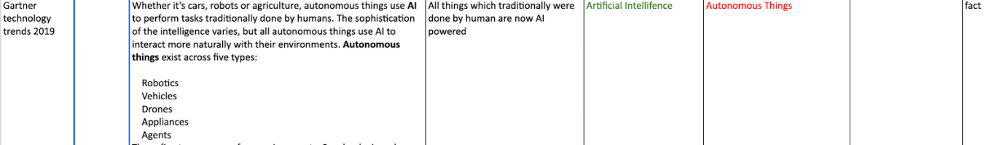Figure 3.1.1 The application of AI Autonomous Things

Further, we found that autonomous things are mainly used in controlled environments now, like the warehouse, but they will finally move to open public spaces (Panetta, 2019) and spread to many industries (Panetta, 2020). Our data also demonstrated this trend with examples in various industries, for example, delivery, warehouse, construction, agriculture, and human resource (Figure 3.1.2).

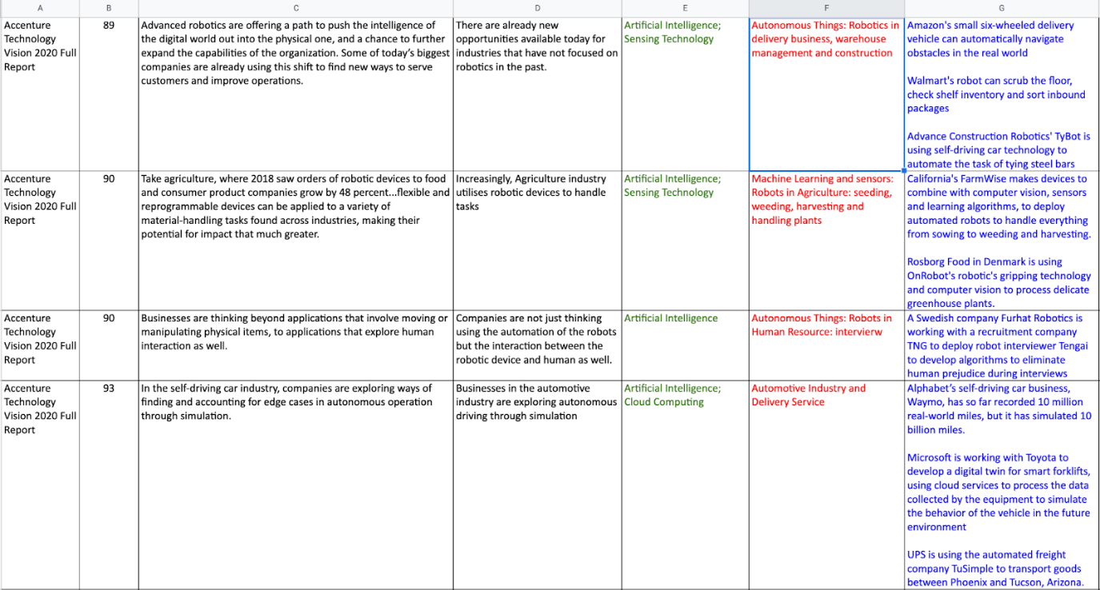Figure 3.1.2 AI application in industries

**How enterprises could utilise the technology**

From the analysis, we discovered the following gaps that could possibly be solved by using AI or AI with other technologies:

* Human-AI collaboration
* Beta-burden
* Constant evolution
* Limit capability in the open world
* Autonomous operation via simulation
* Personal training
* 24/7 automatic response

**Human-AI collaboration**

One of the main advantages provided by AI is that it allows start-ups to subvert decades-old companies, but the technology cannot transform the business on its own. Organisations must search for new ways, new tools which will allow human & machines to better collaborate. For machines and humans to collaborate better, they must first both understand each other (Biltz et al., 2020).

“*To start reimagining the organization, enterprises need to facilitate and enable true human-AI collaboration*” (Biltz et al., 2020).

**Solution**

Natural language processing (NLP), explainable AI and extended reality (XR) will all unlock new ways for humans to interact with machines and for machines to interact with us (Biltz et al., 2020).

**Example**

Casetext, a start-up building an AI-powered research platform for lawyers, named CARA, has applied techniques similar to the BERT approach (Biltz et al., 2020).

OpenAI’s MuseNet, an AI that collaborates with humans to compose music, without people needing expertise in composition or technology (Biltz et al., 2020).

**Beta-burden**

Treating the product as everything in the customer relationship and treating it as everything will increase the burden on Beta and severely limit the company's future development potential (Biltz et al., 2020).

**Solution**

Experience-driven and updatable products can introduce a new ownership model, that is, even if the customer purchases the equipment, the company must retain some control and responsibility for the equipment (Biltz et al., 2020).

**Example**

Shiseido has developed the Optune application to bring a personalised skincare experience by using AI technology to create uniquely tailored lotions for customers (Biltz et al., 2020).

**Constant Evolution**

Companies need to prepare for the future, hoping to enhance device features long after consumers make the first purchase. Entrepreneurs can reconsider their design process and hardware to ensure that their products have continuous development (Biltz et al., 2020).

**Solution**

Rather than releasing perfect products, businesses can release unfinished products and establish potential growth into their product designs (Biltz et al., 2020).

**Example**

Sony's robot dog Aibo uses sensor-rich hardware and cloud services to expand the value of its equipment in novel and interesting ways (Biltz et al., 2020).

General Motors (GM) has created a "digital nervous system" platform to provide customers with wireless software updates (Biltz et al., 2020).

**Limit capability in open world**

Currently, autonomous things are mainly used in in-door environments, and they still need human control in out-door environments (Biltz et al., 2020).

**Solution**

5G networks will unlock opportunities for all industries to extend their autonomous capabilities from the controlled world, for example, warehouses and production facilities, into uncontrolled spaces (Biltz et al., 2020).

**Autonomous operation via simulation**

Businesses in the automotive industry are exploring autonomous driving through simulation (Biltz et al., 2020).

**Solution**

Apply digital twin in self-driving car industry (Biltz et al., 2020)

**Example**

Alphabet’s self-driving car business, Waymo, has so far recorded 10 million real-world miles, but it has simulated 10 billion miles (Biltz et al., 2020).

Microsoft is working with Toyota to develop a digital twin for smart forklifts, using cloud services to process the data collected by the equipment to simulate the behaviour of the vehicle in the future environment (Biltz et al., 2020).

UPS is using the automated freight company TuSimple to transport goods between Phoenix and Tucson, Arizona (Biltz et al., 2020).

**Personalised training**

Now the university enrolment rate is declining, and it is also facing the problem of high dropout rate. Also, college students need a more engaged and personalized way of learning (Neelakantan, 2020).

**Solution**

Introducing conversation platforms, for example, the virtual assistant, to deliver customised learning experience in higher education (Neelakantan, 2020).

**Example**

IBM Research cooperated with Rensselaer Polytechnic Institute to help students learn Mandarin. They use an AI-powered assistant with an immersive classroom environment to make learners feel they are in a restaurant in China where they can practice speaking Mandarin with the AI assistant (Neelakantan, 2020).

**24/7 Automatic response**

In universities, freshmen can have many questions about enrolment and the various required forms, but they have no idea about which campus office to go for specific queries. Also, many queries from students are consistently repeated, and it is impossible for a regular assistant to handle a volume of similar queries (Neelakantan, 2020).

**Solution**

Creating a system that could respond to or communicate with user queries that are consistently repeated and released the system onto the message board (Neelakantan, 2020).

**Example**

Georgia State University introduced an AI chatbot, Pounce. “Summer melt” occurs when students who enrol in the spring drop out by the time school begins in the fall (Neelakantan, 2020).

Georgia Institute of Technology uses a virtual teaching assistant, Jill Watson, to answer questions (Neelakantan, 2020).

**3.2 Cloud Computing**

By analysing the data, we directly generated Cloud Computing from the raw data as a one of the technology themes (refer to Figure 3.2.1 & 2).

*“Just as the advent of cloud computing upended the notion of a software ‘update’...”*

(Biltz et al., 2020)

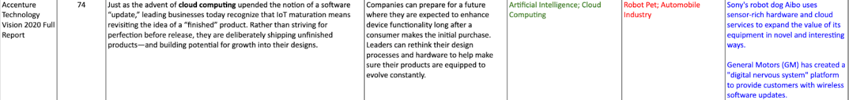Figure 3.2.1 the technology theme: Cloud Computing

*“The evolution from centralized public cloud to distributed public cloud ushers in a new era of cloud computing” (*Panetta, 2019)

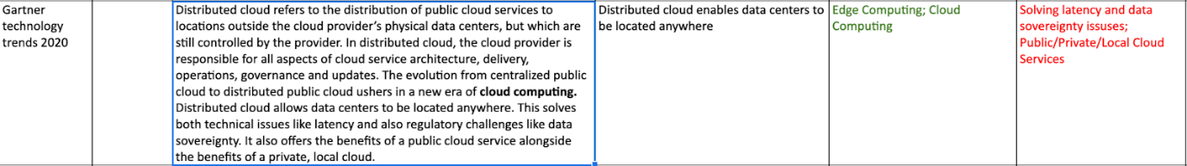Figure 3.2.2 the technology theme: Cloud Computing

We also did online search to find the definition of “Cloud Computing”. On the website of Microsoft Azure, they define it as:

*“cloud computing is the delivery of computing services—including servers, storage, databases, networking, software, analytics, and intelligence—over the Internet (“the cloud”) to offer faster innovation, flexible resources, and economies of scale.”* (Microsoft Azure, 2021)

Based on the above definition, we were able to generate “Cloud Computing” from the extracted information that does not contain “Cloud” or “Cloud Computing” (refer to Figure 3.2.3).

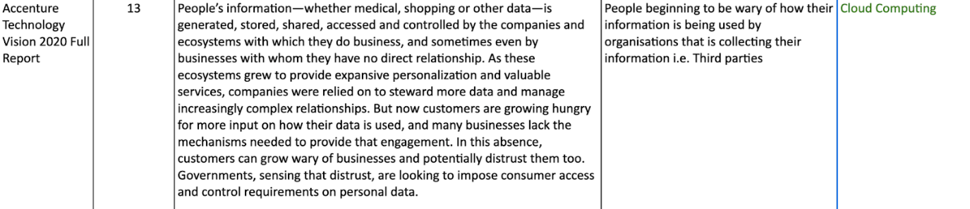Figure 3.2.3 The extracted data without mentioning Cloud Computing.

Based on the definition, we classified the following emerged applications into Cloud Computing:

* Virtual Education
* Data Storage
* Product’s Longer lifecycle

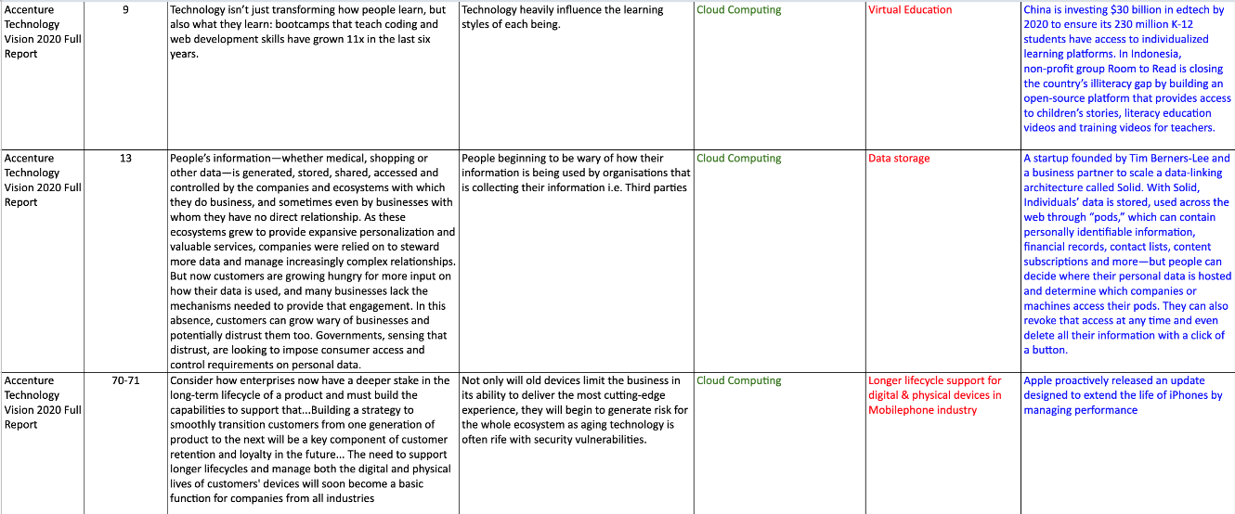Figure 3.2.4 The applications of Cloud Computing

**How enterprises could utilise the technology**

From the analysis, we discovered the following gaps that could possibly be solved by using Cloud Computing:

* Access and control of personal data
* Aging devices performance

**Access and control of personal data**

Personal information is generated, stored, shared, accessed and controlled by the businesses and their commercial partners. People are beginning to be wary of how their information is being used by organisations that are collecting their information. Also, customers would like more input on how their data is used (Biltz et al., 2020).

**Solution**

Data storage and use

**Example**

A start-up creates a data-linking architecture called Solid. With Solid, personal data can be stored and used online through a “pod”, which can include personally identifiable information, financial records, contact lists, and content subscriptions. In addition, people can decide where to host their personal data and determine which companies or machines can access their pods. They can also revoke that access at any time, and even delete all their information by clicking a button (Biltz et al., 2020).

**Aging devices performance**

Not only will old devices limit the business in its ability to deliver the new experience, but they will also begin to generate risk for the whole ecosystem as aging technology is often rife with security vulnerabilities (Biltz et al., 2020).

**Solution**

Longer life cycle support for digital & physical devices in mobile phone industry (Biltz et al., 2020).

**Example**

Apple proactively releases software updates designed to extend the life of iPhones by managing performance (Biltz et al., 2020).

**3.3 Edge Computing**

According to Panetta (2017), Edge computing is a computing topology that has the ability to put content, computing, and processing closer to the user or things, so traffic can be kept locally to reduce latency. The technology theme, Edge Computing, was directly generated from the data.

*“Edge computing describes a computing topology in which information processing and content collection and delivery are placed closer to the sources of this information... Edge computing speaks to a computing topology that places content, computing, and processing closer to the user/things or “edge” of the networking.”* (Panetta, 2017)

Based on the above definition, we were able to generate “Edge Computing” from the data analysis when it mentioned processing data and make decisions “locally” (refer to Figure 3.3.1).

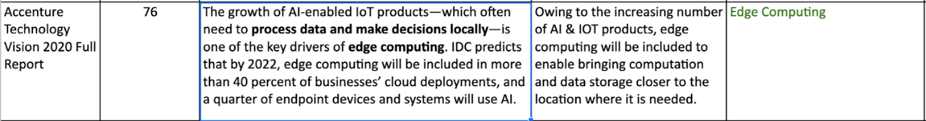Figure 3.3.1 The technology theme: Edge Computing

The analysis revealed that the increasing number of AI & Internet of Things (IoT) products become the key driver to deploy edge computing in businesses’ cloud infrastructure (Biltz et al., 2020). Because those products often require computation and data storage being closer to the location where it is needed.

**How enterprises could utilise the technology**

From the analysis, we discovered the following gaps that could possibly be solved by using Edge Computing or Edge Computing with other technologies:

* Privacy & security
* Central computation & data storage
* Latency

**Privacy & Security**

Data that allows companies to power valuable, individualised experiences to customers also create a risk to privacy and security (Biltz et al., 2020).

**Solution**

In home security systems, using edge products themselves to host AI lets companies store and analyse user data locally, rather than sending it to a central cloud (Biltz et al., 2020).

**Example**

Simcam, an in-home security system, makes all facial recognition on the device itself instead of sending the data to a central cloud for analysis (Biltz, 2020).

**Central computation**

There is a continuing trend that is away from centralised-only data silos (Reding & Eaton 2020).

**Solution**

Combining AI, IoT with edge computing can enable smart spaces, and moves key applications and services closer to the user and devices that use them (Panetta, 2019).

**Example**

Simcam, an in-home security system, makes all facial recognition data on the device itself instead of sending the data to the central cloud for analysis (Biltz, 2020).

**Latency**

Businesses that have many IoT elements could encounter challenges of connectivity latency (Panetta, 2017).

**Solution**

Enterprises should start using the technology in their infrastructure architectures, for example, public, private, and local cloud services (Panetta, 2019)

**3.4 Internet of Things (IoT)**

According to Bayani & Quesada (2017), IoT is considered as an interconnected network that can collect and exchange data from intelligent physical objects with embedded sensors, RFID tags and actuators. The technology theme, IoT, was directly generated from the raw data.

*“The basic idea of (IoT) is a new model based on the presence of a variety of objects like Radio Frequency Identification (RFID) tags, sensors and actuators that are able to interact with each other. It is considered as the internetworking of smart physical objects that are enabled to collect and exchange data through the unique IPv6 addressing schemes. Also, it refers to the use of smartly connected objects, agents, and devices to manage data obtained by embedded sensors in machines and other physical-virtual objects”* (Bayani & Quesada, 2017)

Moreover, IoT has been defined as the global infrastructure to improve the interconnection across various types of objects in an information society (refer to Figure 3.4.1).

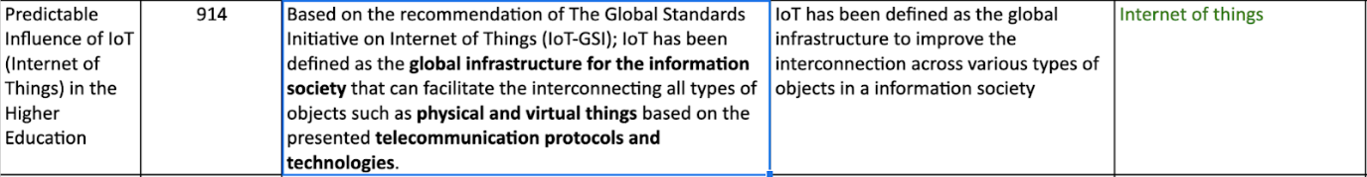Figure 3.4.1 The technology theme: IoT

Using the above IoT definition, we were able to group the following emerged applications into the technology theme of IoT.

* Connectivity (wired & wireless)
* Smart Objects
* Smart Industries & Cities
* Telematics
* Virtual Education

Specifically, our analysis revealed that hyper connectivity is considered as the characteristic of IoT (refer to Figure 3.4.2). In addition, one of the most common applications of IoT is in online education (Bayani & Quesada, 2017).

Figure 3.4.2 The application of IoT: Connectivity

Moreover, we found that connected traffic, utilities, public safety, and environmental monitoring are the typical IoT projects of smart cities (refer to Figure 3.4.3). Also, Telematics and fleet management are the typical IoT applications in the transportation industry (refer to Figure 3.4.4). IoT has been utilised in many industries, for example, the transportation, energy, and retail (refer to Figure 3.4.4).

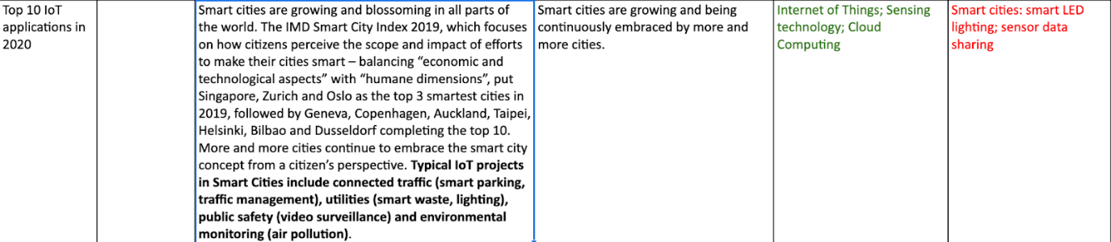Figure 3.4.3 The application of IoT: Smart Cities

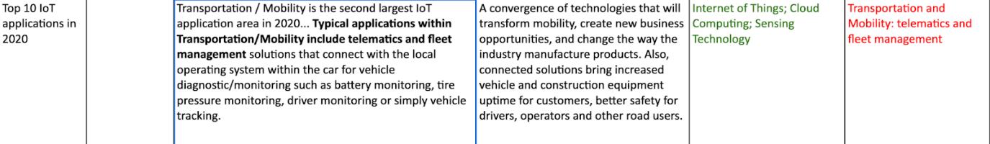Figure 3.4.4 The application of IoT: Telematics

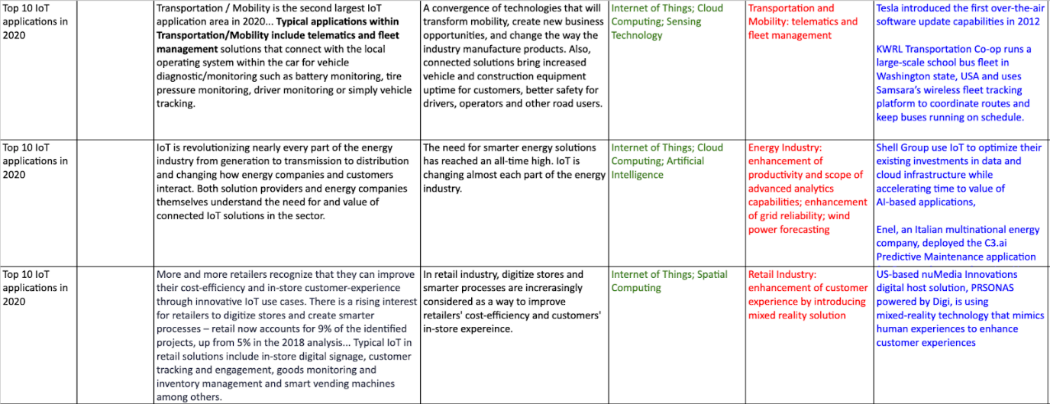Figure 3.4.5 IoT applications in industries

**How enterprises could utilise the technology**

From the analysis, we discovered the following gaps that could possibly be solved by using IoT or IoT with other technologies:

* Ownership of products
* Smart energy
* Cost-efficiency & in-store customer experience
* Increased end customer & complexity
* Simple deployment & low-cost ownership
* Building management
* Transport & mobility
* Manufacturing control
* Demand for health applications

**Ownership of products**

The majority of entrepreneurs believe their industry is turning to provide more variety in ownership models for their connected products/services (Biltz et al., 2020).

**Solution**

Cooperating with other companies to offer variety in ownership models (Biltz et al., 2020)

**Example**

Caterpillar is being integrated with Cat Connect to introduce remote telematics-driven services for customers (Biltz et al., 2020).

Samsung has integrated products from different companies with its own SmartThings application to expand the functionality of their home appliances (Biltz et al., 2020).

**Smart energy**

The demand for smarter energy solutions has reached a high level, and IoT is changing almost every part of the energy industry (Scully, 2020).

**Solution**

Combining AI with IoT infrastructure to better use the data collected from IoT devices, to get enhancement of productivity and scope of advanced analytics capabilities, enhancement of grid reliability, and optimise wind power forecasting (Scully, 2020).

**Example**

Shell Group use IoT to optimize their existing investments in data and cloud infrastructure while accelerating time to value of AI-based applications (Scully, 2020)

Enel, an Italian multinational energy company, deployed the C3.ai Predictive Maintenance application for 5 control centres by using AI to analyse real-time network sensor data, smart meter data, asset maintenance records, and weather data to predict feeder failure (Scully, 2020).

American utility company, Exelon, optimizes wind forecasting accuracy with GE’s Predix Platform. GE’s data science team incorporated diverse data sources, ran the analytics in Predix Cloud, and wrote back the results quickly (Scully, 2020).

**Cost-efficiency & in-store customer experience**

In the retail industry, digitised stores and smarter processes are increasingly considered as a way to solve problems related to cost and customer experience in the retail industry.

**Solution**

in-store digital signage, customer tracking and engagement, goods monitoring and inventory management and smart vending machines among others (Scully, 2020).

**Example**

US-based nuMedia Innovations digital host, PRSONAS powered by Digi, is introducing mixed-reality technology that mimics human experiences to enhance customer experiences (Scully, 2020).

**Increased end customers & complexity**

In the supply chain industry, the delivery of goods flows becomes more complex than before as the industry extends to more and more end customers (Scully, 2020).

**Solution**

Using integrated connected digital solutions to cope with complexity in dock and shipment monitoring (Scully, 2020).

**Example**

Rotterdam Port is using sensors throughout their expansive dock facility to continuously gather real-time data to explore connected container solutions to gather data and use artificial intelligence to predict more accurately what the best time is to moor and depart cargo ships at ports (Scully, 2020).

DHL is trialling smart pallets for real time shipment monitoring (Scully, 2020).

**Simple deployment & low cost of ownership**

Farmers need technologies that have simplicity of deployment and low cost of ownership to make it possible to expand per-acre coverage and monitor more assets (Scully, 2020).

**Solution**

LPWANs are ideal for using sensors to collect data of local agricultural conditions, such as weather, soil moisture, soil chemical compositions and other environmental information at a lower total cost of ownership. LPWAN is making the way for Smart Agriculture’s growth in IoT (Scully, 2020).

**Example**

Kwekerij Moors Pepper Farm adjusts the connected greenhouse climate according to the data collected from sensors (Scully, 2020).

Hake Dairy farmer in Wagenfeld-Ströhen, Germany uses IoT connected dairy farm solutions to monitor cow's growth (Scully, 2020).

**Building management**

Many organizations invest in smart building control system improvements, aiming to improve productivity and efficiency through complete building lifecycle management, while reducing operating costs (Scully, 2020).

**Solution**

Facility-automation and monitoring for building systems, building utilization and security, visualisation of processes (Scully, 2020).

**Example**

At its Innovation Test Tower in Rottweil, Germany, ThyssenKrupp Elevator is using Willow Twin, a digitalized virtual model of the physical building, to revolutionize the way buildings are maintained and to enhance the experience of tenants and visitors (Scully, 2020).

A shopping centre in the Leppävaara district of Espoo, Finland is using Navigator software, from Siemens and eggsunimedia, to monitor and analyse the ventilation systems, room sensors and lighting systems in the multitude of premises and shops (Scully, 2020).

**Traditional transportation and mobility**

The industry requires technology to increase vehicle and construction equipment uptime, and have better safety for drivers, operators, and other road users.

**Solution**

Telematics and fleet management solutions that connect with the local operating system within the car for vehicle diagnostic and monitoring like battery monitoring, tire pressure monitoring, driver monitoring or simply vehicle tracking (Scully, 2020).

**Example**

Tesla introduced the first over-the-air software update capabilities in 2012 (Scully, 2020).

KWRL Transportation Co-op runs a large-scale school bus fleet in Washington state, USA and uses Samsara’s wireless fleet tracking platform to coordinate routes and keep buses running on schedule (Scully, 2020).

OnniBus.com, a leading long-distance bus service in Finland, building a more streamlined and sustainable transport operation with Telia’s connected vehicle solution (Scully, 2020).

Caledonian Logistics, based in Aberdeen, Scotland, uses MyGeotab for fleet monitoring and tracking driver behaviour (Scully, 2020).

**Manufacturing control**

Manufacturers and industrial operators are discovering practical ways to combine technologies and expertise in specific industrial applications to improve collaboration, problem-solving speed, and productivity (Scully, 2020).

**Solution**

IoT can be applied in a wide range of connected “things” both inside and outside the factory (Scully, 2020).

Inside: floor monitoring, wearables and Augmented Reality on the shopfloor, remote PLC (programmable logic controller) control, automated quality control systems.

Outside: remote control of connected machinery, equipment monitoring, management and control of entire remote industrial operations (i.e., oil rigs).

**Example**

Howden, a Scottish manufacturer of air and gas handling solutions, turned to Microsoft and PTC to develop scalable mixed reality solutions that overlay real-time IoT data from connected products with 3D Augmented Reality experiences to provide instructions on how to solve problems with the equipment (Scully, 2020).

**Demand for health applications**

Because of COVID-19 pandemic, demand for specific IoT health applications is increasing, including telehealth consultations, digital diagnostics, remote monitoring, and robot assistance.

**Solution**

Typical IoT applications in the healthcare industry: medical device monitoring, health team coordination, optimizing workflow operations, patient monitoring, assisted living, elderly care, and pain medication management (Scully, 2020).

**Example**

Medisanté are simplifying remote patient monitoring with continuous monitoring of assets connected to healthcare applications, which allows personalized patient care and equips care teams with a near real-time view of the patient’s health and activities (Scully, 2020).

Medtronic offers connected pacemakers to implant in the heart patient's chest or abdomen. The device gathers data and can stimulate the heart muscle with electricity pulses that restore the heart’s rhythm to a normal rate (Scully, 2020).

**3.5 Quantum Technology**

According to Reding & Eaton (2020), Quantum Technology is a class of technology that works by using the principles of quantum mechanics, Quantum Computing and Quantum Cryptography are examples of Quantum technology.

From the analysis, we found that Quantum Technology will greatly benefit IoT applications by increasing capabilities of data collection, processing, and exploitation, improving sensor capabilities, secure communications, and computing (Reding & Eaton, 2020).

The technology theme, Quantum Technology, was generated from the data.

*“Next-generation quantum technologies exploit quantum physics and associated phenomena at the atomic and subatomic scale; in particular, quantum entanglement and superposition. These effects support significant technological advancements primarily in cryptography; computation; precision navigation and timing; sensing and imaging; communications; and materials...”* (Reding & Eaton, 2020)

Quantum encryption enables computation on encrypted data without the need to decrypt it first, and the data can be transported, processed by a third party without letting that party see the data they are working with (Biltz et al., 2020).

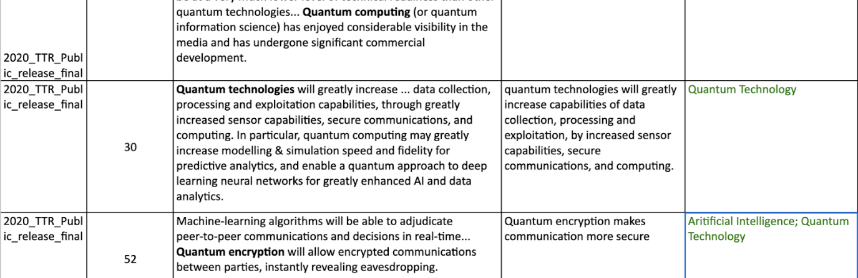Figure 3.5.1 The technology theme: Quantum Technology and its applications

Based on the definition and the extracted data, two applications were emerged from the data (refer to Figure 3.5.1):

* Quantum Computing
* Quantum Cryptography (Quantum Encryption)

**How enterprises could utilise the technology**

From the analysis, we discovered the following gaps that could possibly be solved by Quantum Technology:

* Data security
* Secure communication

**Data Security**

It is especially important for organisations to protect data from being seen when processing data that holds confidential information or customer details because more control and privacy can foster more customer trust (Biltz et al., 2020).

**Solution**

Quantum homomorphic encryption can be used to protect voter’s information (Biltz et al., 2020).

**Example**

Travis County, Texas is developing a voting system that can analyse the voting data while still being encrypted without touching the actual voting (Biltz et al., 2020).

**Secure Communications**

Secure communications are crucial in exchanging information in a connected world, especially in the commercial world.

**Solution**

Quantum encryption will allow encrypted communications between parties, and eavesdropping can be exposed (Reding & Eaton, 2020).

**3.6 Sensing Technology**

The analysis revealed that sensors were used in various industries, for example, agriculture, logistics, energy, and they are one of the key hardware across IoT and AI applications (refer to Figure 3.6.1). Kenco, an American logistics company, reported that 56% of professionals from the supply chain industry are currently or going to invest in sensors (Scully, 2020). Also, ubiquitous sensing will be available by the growth of 5G communication and IoT (Reding & Eaton, 2020).

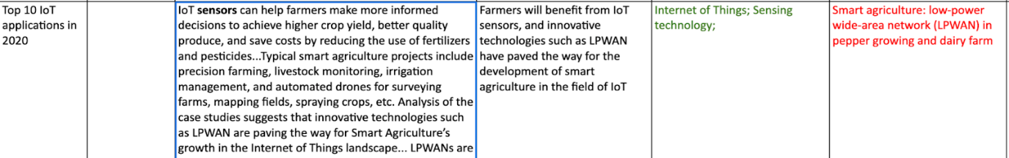Figure 3.6.1 The technology theme: Sensing Technology

The keyword, sensors, appeared often in the data. They are the devices that have functions to detect and track objects or changes in the environment, and process data (Reding & Eaton, 2020). Eventually, we placed sensors into an independent technology theme, Sensing Technology, rather than include it into IoT or AI.

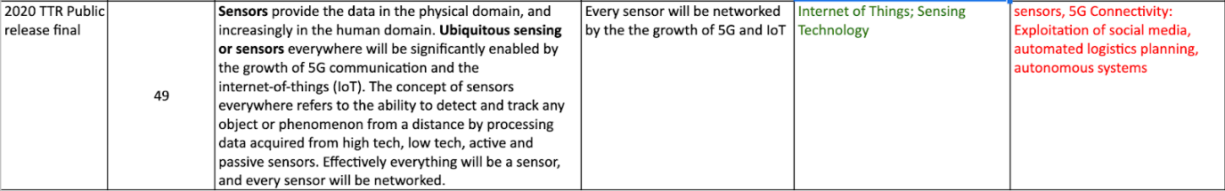Figure 3.6.2 The application of Sensing Technology

**How enterprises could utilise the technology**

From the analysis, we discovered the following gaps that could possibly be solved by using Sensing Technology or Sensing Technology with other technologies:

* IoT connected devices.
* Autonomous things

**IoT connected devices.**

IoT requires more hardware smart devices to be involved, such as sensors. They can observe, monitor, collect and analyse the collected data. Designing flexible products by embedding intelligence into physical devices to support new functions where possible (Biltz et el., 2020).

**Solution**

Embedded sensors in physical objects to obtain data in smart cities and the energy industry, the supply chain and shopping centres.

**Example**

Amsterdam employed 144 LED smart streetlights along with cameras and a public WIFI network in Hoekenrode Plein square (Scully, 2020).

Singapore uses an integrated sensor platform, Smart Nation Sensor Platform, to collect, analyse, and share data from connected sensors and devices to improve urban planning, transportation, and public safety in the island (Scully, 2020).

Enel, an Italian multinational energy company, deployed the C3.ai Predictive Maintenance application for 5 control centres by using AI to analyse real-time network sensor data, smart meter data, asset maintenance records, and weather data to predict feeder failure (Scully, 2020).

Rotterdam Port is using sensors throughout their expansive dock facility to continuously gather real-time data to explore connected container solutions to gather data and use artificial intelligence to predict more accurately what the best time is to moor and depart cargo ships at ports (Scully, 2020).

DHL is trialling smart pallets for real time shipment monitoring (Scully, 2020).

A shopping centre in the Leppävaara district of Espoo, Finland is using Navigator software, from Siemens and eggsunimedia, to monitor and analyse the ventilation systems, room sensors and lighting systems in the multitude of premises and shops (Scully, 2020).

**Autonomous things**

Autonomous things, which include drones, robots, ships, and appliances, use AI to perform tasks normally done by humans. It provides transformational chances to the commercial world. More importantly, the function of sensors is one of the conditions to determine specific levels of autonomy (Reding & Eaton, 2020).

**Solution**

Using sensor in automated robots in industries: agriculture, delivery, warehouse, construction.

**Example**

California's FarmWise makes devices to combine with computer vision, sensors and learning algorithms, to deploy automated robots to handle everything from sowing to weeding and harvesting (Biltz et el., 2020).

Kwekerij Moors Pepper Farm adjusts the connected greenhouse climate according to the data collected from sensors (Scully, 2020).

Hake Dairy farmer in Wagenfeld-Ströhen, Germany uses IoT connected dairy farm solutions to monitor cow's growth (Scully, 2020).

Amazon's small six-wheeled delivery vehicle can automatically navigate obstacles in the real world (Biltz et el., 2020).

Walmart's robot can scrub the floor, check shelf inventory and sort inbound packages (Biltz et el., 2020).

Advance Construction Robotics' TyBot is using self-driving car technology to automate the task of tying steel bars (Biltz et el., 2020).

**3.7 Spatial Computing**

Augmented Reality (AR), Virtual Reality (VR) and Mixed Reality (MR) were initial themes directly generated from the data because they were mentioned in the extracted information (refer to Figure 3.7.1). However, the analysis result showed us a certain degree of similarity among the three technologies, and we were considering if there was another term to describe those technologies.

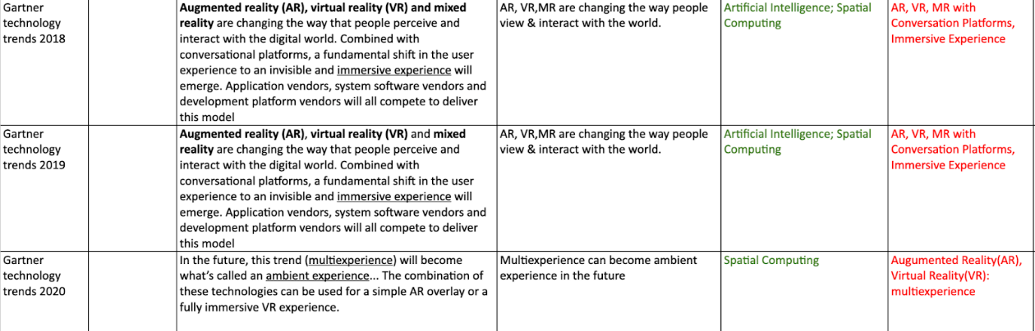Figure 3.7.1 AR, VR, MR generated from extracted data.

Therefore, we did an online search to check if there was a technology that could include AR, VR and MR in one group. Eventually, we found “Spatial computing”. It is about the interaction between humans and machines, where the machine keeps and handles references to real objects and spaces. It is an important part of making our machines a more satisfying work and entertainment partner (Greenwold, 2003).

Based on the above information of Spatial computing, we classified the following applications Spatial computing:

* Augmented Reality (AR)
* Virtual Reality (VR)
* Mixed Reality (MR)

From the analysis, Spatial Computing has been used in the industries like entertainment, event infrastructure, conversation platforms, manufacturing, retail (refer to Figure 3.7.2).

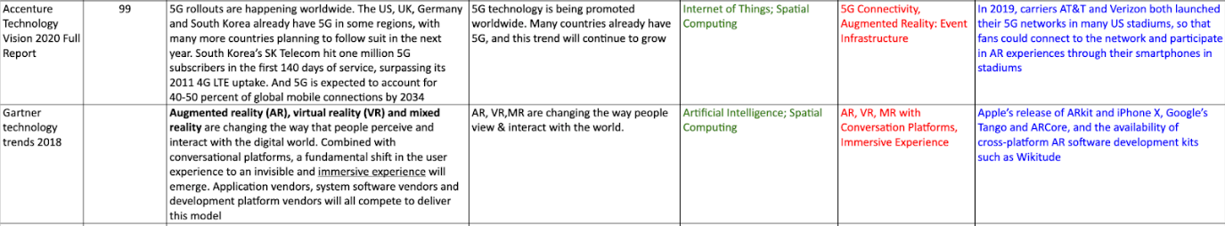Figure 3.7.2 Spatial Computing applications in event infrastructure & conversation platforms

**How enterprises could utilise the technology**

From the analysis, we discovered the following gaps that could possibly be solved by using Spatial computing or Spatial computing with other technologies:

* Customised & cooperative entertainment experiences.
* in-store customer experience
* Conversation platforms
* Manufacturing control

**Customised & cooperative entertainment experiences.**

Shifting passive audiences into active participants by changing one-way experiences to cooperative experiences. It is important because being a real partner of customers will be the crucial factor for companies’ future (Biltz et al., 2020).

**Solution**

AR in customised & cooperative entertainment experiences by including engagement with users.

**Example**

In Netflix’s Black Mirror: Bandersnatch, viewers make decisions for the main character—listen to this song, throw that cup of tea, bury the body. It is an interactive choose-your-own-adventure episode of the larger sci-fi series, with five possible endings and millions of ways to get there (Biltz et al., 2020).

Steam Labs is experimenting with a new game recommendation system. The company's interactions include recommendations based on a user's gaming history, as well as the player’s feelings at the time. Players use sliders to help them generate recommendations based on their current interests (Biltz et al., 2020).

**In-store customer experience**

In the retail industry, digitized stores and smarter processes are increasingly considered as a way to improve retailers' cost-efficiency and customers' in-store experience.

**Solution**

In-store digital signage, customer tracking and engagement, goods monitoring and inventory management and smart vending machines among others (Scully, 2020).

**Example**

US-based nuMedia Innovations digital host, PRSONAS powered by Digi, is introducing mixed-reality technology that mimics human experiences to enhance customer experiences (Scully, 2020).

**Conversation Platforms**

Providers in the software development industry will all compete to deliver a model to turn the user experience into an invisible and immersive experience (Panetta, 2017).

**Solution**

Use AR, VR, MR to provide immersive experience (Panetta, 2017).

**Example**

Apple’s release of ARkit and iPhone X, Google’s Tango and ARCore, and the availability of cross-platform AR software development kits such as Wikitude (Panetta, 2017).

**Manufacturing control**

Manufacturers and industrial operators are discovering practical ways to combine technologies and expertise in specific industrial applications to improve collaboration, problem-solving speed, and productivity (Scully, 2020).

**Solution**

IoT can be applied in a wide range of connected “things” both inside and outside the factory (Scully, 2020).

Inside: floor monitoring, wearables and Augmented Reality on the shopfloor, remote PLC (programmable logic controller) control, automated quality control systems.

Outside: remote control of connected machinery, equipment monitoring, management and control of entire remote industrial operations (i.e., oil rigs).

**Example**

Howden, a Scottish manufacturer of air and gas handling solutions, turned to Microsoft and PTC to develop scalable mixed reality solutions that overlay real-time IoT data from connected products with 3D Augmented Reality experiences to provide instructions on how to solve problems with the equipment (Scully, 2020).

# **4. Outcome**

This section introduces a developed tool that can help various small to medium size enterprises to apply emerging technology solutions in their organisations. Also, two scenarios will be used to test the tool.

The tool is built on a Microsoft Excel spreadsheet, and it includes:

* A content of emerging technologies and applications
* A map of gaps
* Sub-spreadsheets for each technology

**How to use the tool**

Once the tool is downloaded, double click the file to open the document, and look in a table called “Contents” for an overview of all emerging technologies and their applications.

Look in the bottom bar of the document, Click the *Gaps Map* tab. Scroll down to browse a brief version of gaps, solutions, and examples for each technology.

Use the bottom tabs labelled by technology names to shift to another sub-spreadsheet that you would like to go. For example, click *Artificial Intelligence* tab, scroll down to check detailed information of the technology, such as the facts, applications, and examples.

Alternatively, click the menu button (displayed as **≡**) at the bottom left corner of the document. You will notice that a list appears on the document. It contains the names of all sub-spreadsheets for document. Select the one you would like to go, then click on it.

To look up a keyword or technologies that could solve a specific gap, use *[CTRL] + F* within the spreadsheet.

Once the small searching box appears on the spreadsheet, enter a keyword. You will notice that cells containing the keyword are highlighted in green across the sub-spreadsheets.

In the searching box, you will see a number showing the total number of matched cells and a pair of arrows. Use the arrows to check the next or previous matching cells. To keep reading the matching information for each technology, click the bottom tabs to shift to another sub-spreadsheet.

For the highlighted information, look for words displayed in green colour on the same row, and they are the technologies that could be used to address the problem.

**Testing: scenario one**

**Problem**: Manage inventory to track and monitor medical supplies

**Company**: BJC HealthCare in Missouri and Illinois

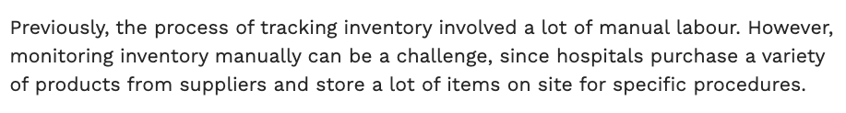

Figure 4.1 The problems of BJC HealthCare inventory management

**Using the tool**

This case assumes that the user has downloaded and opened the tool.

Once the tool is opened, Click the *Gaps Map* tab at the bottom bar of the document.

Use [CTRL] + F on your keyboard to open the searching box.

Enter one of the keywords emerged from the organisation’s problem, like “inventory”.

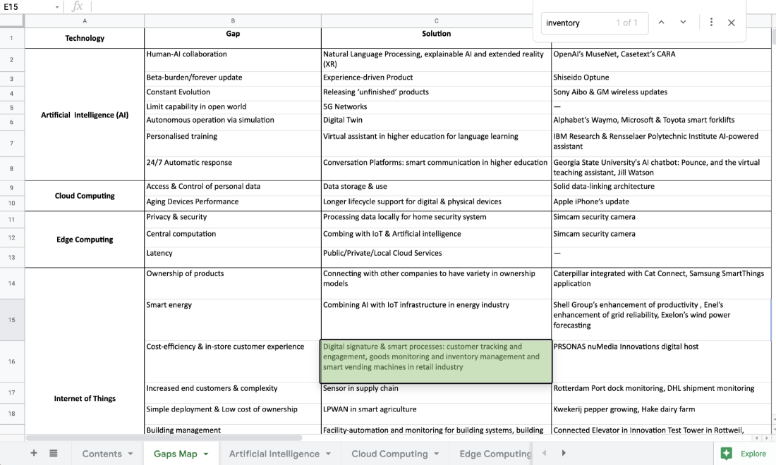

Figure 4.2 Searching the spreadsheet tool by entering “inventory”.

From Figure 4.2, we can find that there is one matching result in the *Gaps Map*, and the cell is highlighted in green. The highlighted information is the solution of using digital signature and smart process to achieve cost-efficiency and to enhance in-store customer experience. PRSONAS is the real-world example by applying the solution.

Next, locate the technology that the highlighted cell belongs to. In this case, Internet of Things is the answer.

Click *Internet of Things* tab at the bottom bar of the document. Click the keyword in searching box, and press *Enter* on your keyboard to make sure the searching box is activated on the current sub-spreadsheet.

You will notice that there are two searching results showing on the top right corner. Use the pair of arrows to go to the next or previous result (refer to Figure 4.3 & Figure 4.4).

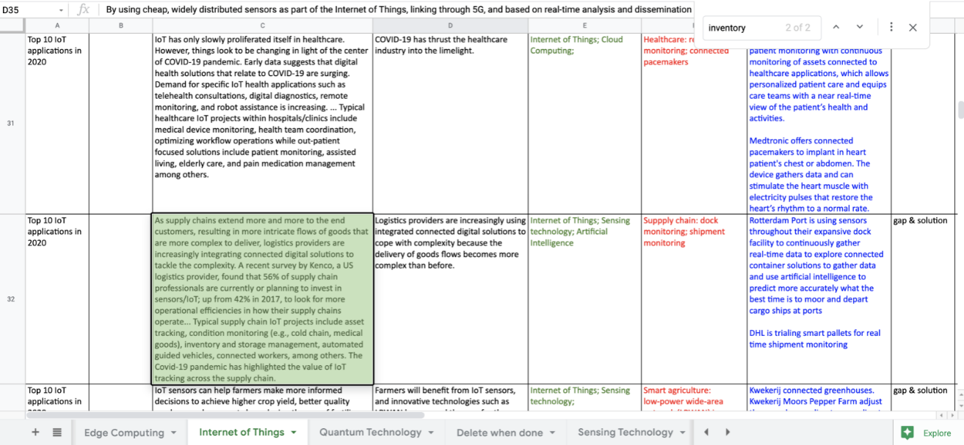

Figure 4.3 Searching result under IoT tab.

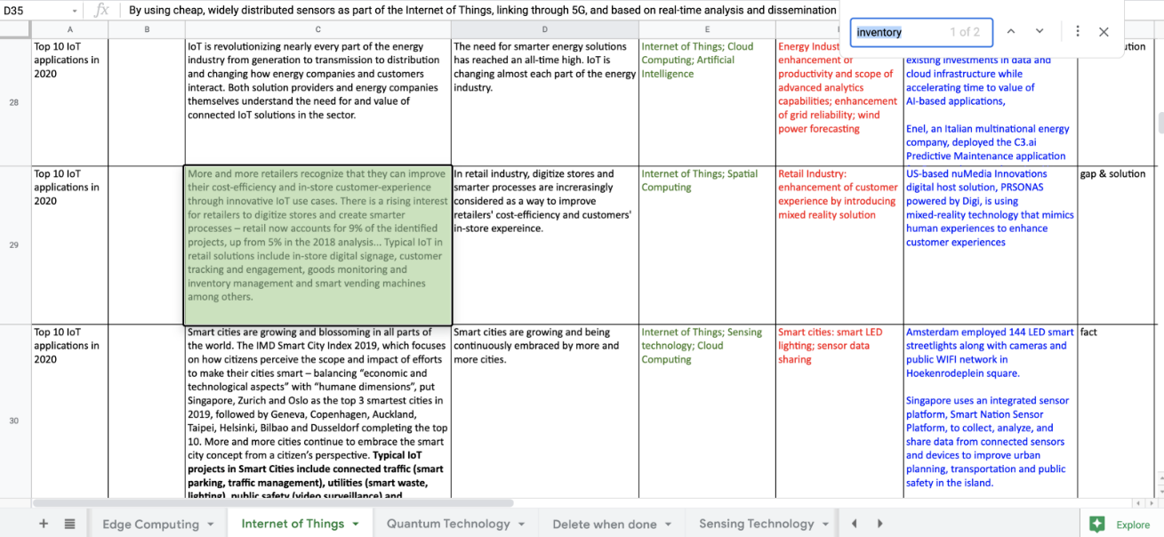

Figure 4.4 Searching result under in IoT tab.

Click *Artificial Intelligence* tab to check if there are any searching results. Two results are found, and one of them is same in Internet of Things tab (refer to Figure 4.5). Use the same way to check for the remaining technology tabs, use the gathered technology to form a solution.

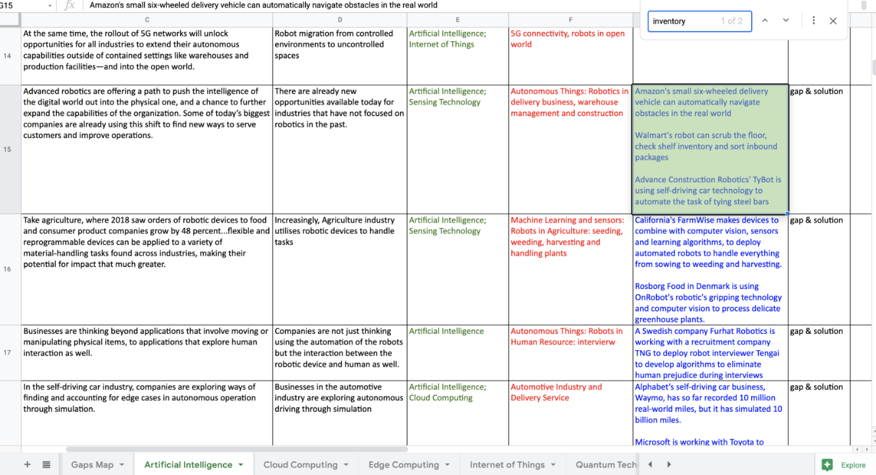Figure 4.5 Searching result under in AI tab.

**Solution**:

The searching results from the tool shows that Sensing technology, Internet of Things, Artificial Intelligence could be used to address BJC Healthcare’s problem. Specifically, sensors are worth to invest because they need to track and monitor supplies. Also, Internet of Things has typical applications in condition monitoring and inventory management which is suitable for this case scenario. Artificial intelligence can also be included into the solution because there is an example of using robots to do inventory check, it could save manual labour for the organisation.

**Testing: scenario two**

**Problem**: School buses are not running on schedule, and parents wait for long time, or their children miss the bus.

**Company**: Neshaminy School District, Pennsylvania, US

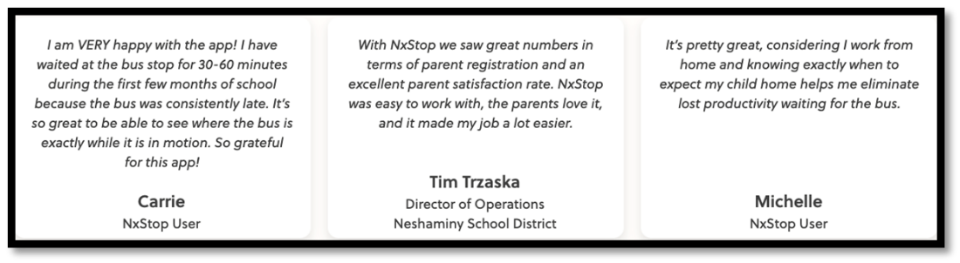

Figure 4.6 The problem of Neshaminy School District’s school buses

**Using the tool**

Once the tool is opened, Click the *Gaps Map* tab at the bottom bar of the document.

Use [CTRL] + F on your keyboard to open the searching box. Enter “vehicle”.

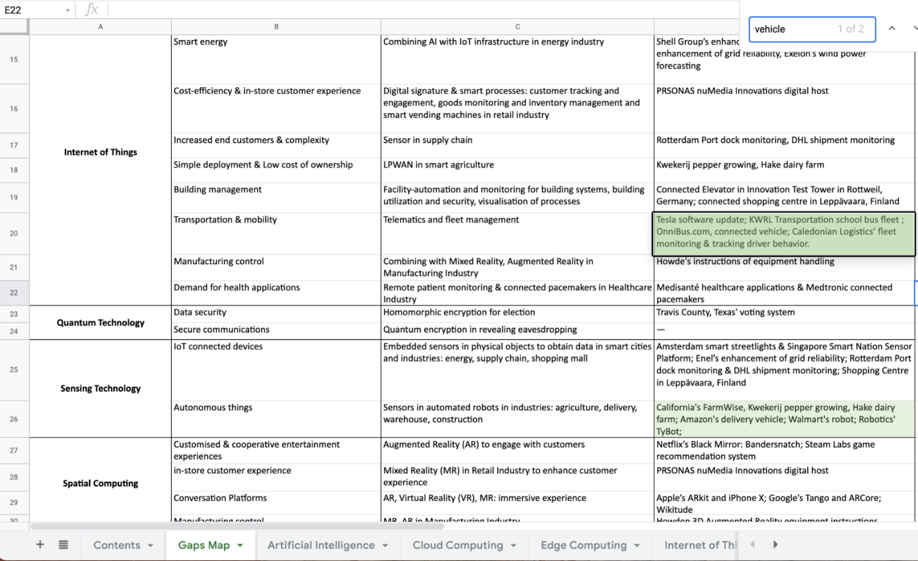Figure 4.7 Searching the spreadsheet tool by entering “vehicle.”

Refer to Figure 4.7, two matching results are highlighted in the Gaps Map. The first highlighted information on the top are examples by using the solutions of telematics and fleet management to address problems related to transportation and mobility. The second one is the case of using sensors to make things autonomously.

Next, locate the technology that the highlighted cell belongs to, which is Internet of Things.

Click *Internet of Things* tab at the bottom bar of the document. Click the keyword in searching box, and press *Enter* on your keyboard to make sure the searching box is still activated on the current page.

You will notice that there are six searching results displayed in the searching box, and three of them are relevant to this scenario (refer to Figure 4.8). Click other tabs to check if there are any different searching results. Using the gathered technologies and information to shape a solution.

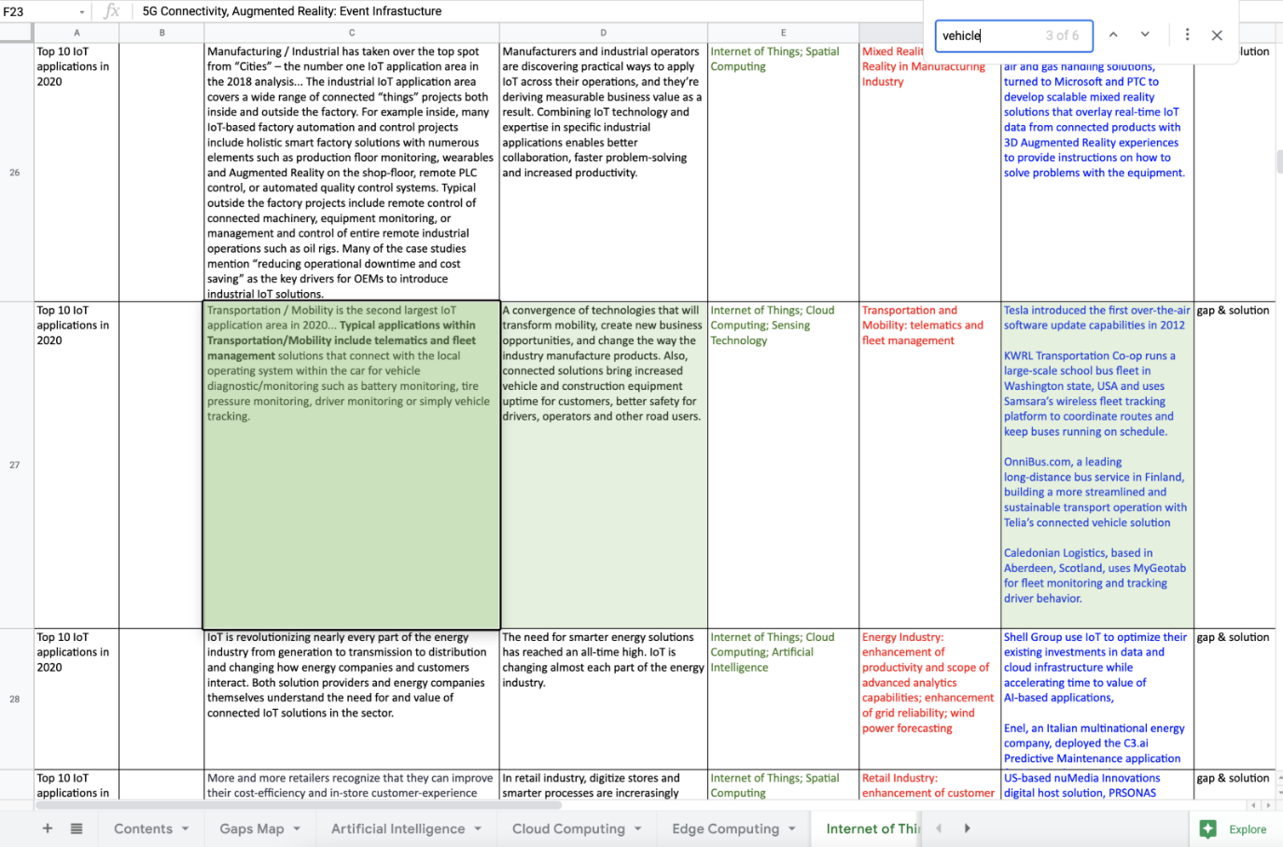Figure 4.8 Searching results under IoT tab.

**Solution**:

The searching results from the tool suggests that Internet of Things, Cloud Computing, Sensing Technology could be used to solve the problem of school buses’ punctuality. Specifically, connected solutions bring increased vehicles and construction equipment's uptime for customers, better safety for drivers, operators, and other road users. For example, KWRL Transportation runs a large-scale school bus fleet in USA and uses Samsara’s wireless fleet tracking platform to coordinate routes and keep buses running on schedule. Caledonian Logistics in Scotland uses MyGeotab for fleet monitoring and tracking driver behavior.

# **5. Project Management**

We did not really have a physical team meeting except during the class. We however talk online via Microsoft teams. Below is the list of chats we had from the first session to the last.

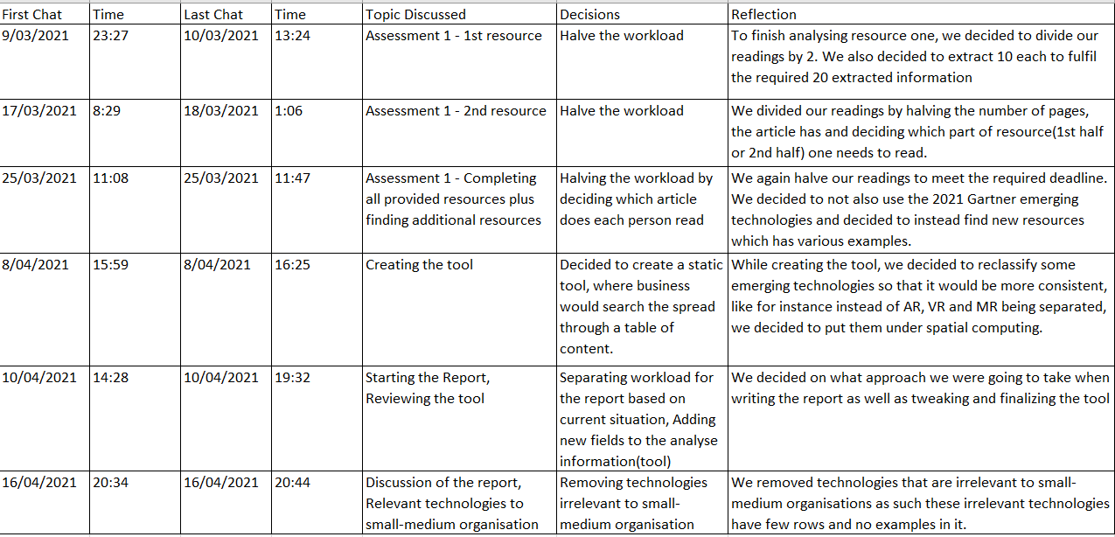Figure 5 List of chats

# **6. Conclusion**

In conclusion, the developed tool will help many businesses solve their issues within their line of operation, since it offers a whole wide range of technologies to choose from. Such tool also offers businesses a wide range of problems that can be solved by the technology as well as examples in real world situations where the technology has been implemented. The tool develop is only at its foundational level, but it will provide a basic background for other people wishing to further develop the tool, of what the potential tool could offer as well as how they can further improve the friendliness of the user interface.

**Summary**

Basically, what we did is read the articles and provided document reports thoroughly. Highlight facts, gaps, solutions, and applications of technologies currently emerging. We then created a spreadsheet listing all extracted data and then categorizing them into their designated technology group. We then further reviewed the names of all found technologies to accurately represent the data. Once data gathering and analysis were done, we then proceeded into the development of a static tool that will be used by organizations and enterprises, a tool developed by creating a table of content, listing each technology found and their applications. We then separated all extracted data into sub sheets of technologies they belong to. Once the tool was created, we then proceeded in the discussion of how the business will utilized the tool, how the technology returned by the tool will solve the daily issues faced by the business.

**Reflection**

This section will discuss the limitation of the tool, what worked and what did not in our project, any suggestions to improve the delivery of outcome, the value of our work and are there anything we contributed to the IT community.

**Limitation**

There are also limitations that exist within the developed tool, such limitations are that not all inputs are guaranteed to get a return answer, that is due to the size of our data. Also due to timeframe, we were only able to analyse 8 articles and document reports such does not cover all technologies that is currently being implemented.

**What worked and did not?**

Everything went well in according to plan that is from the data gathering to the development of tool, however we did encounter some minor issues like for instance we had to research some technologies that were blurry in our minds, as to get a better understanding of what it is about, and does it fit with the data that it is supposed to represent. In doing this, it resulted in reducing time that is focusing on other tasks.

**Suggest how the outcome you delivered may be improved.**

Instead of the tool being static, the tool could be represented as a web application where the business could input a problem they are facing, in a search bar, and be able to get an answer of a list of technologies that would better solve the problem(that is based on ratings of businesses who implemented the technology). Such would allow the potential user to interact more with the tool but also be confident of how the tool will solve their problem.

**IT community Contribution**

With this tool, we are able to contribute to the IT community, a basic foundation of what a potential tool could look or function like. Such tool also offers businesses a knowledge base of what the technology can offer, how it can help them solve their organisation issue.

**What is the value of your work?**

The value of our work is of significant since it provides a basic foundation or a layout of what a potential tool could look like and how businesses would be able to use such tool to solve issues within their business operation.

# **7. References**

Bayani, Majid & Quesada, Enrique. (2017). Predictable Influence of IoT (Internet of Things) in the Higher Education. *International Journal of Information and Education Technology*. 7. 914-920. 10.18178/ijiet.2017.7.12.995.

Biltz, M., Carrel-Billiard, M., & Daugherty, P. (2020). *Technology Vision 2020*. Accenture. https://www.accenture.com/us-en/insights/technology/_acnmedia/Thought-Leadership-Assets/PDF-2/Accenture-Technology-Vision-2020-Full-Report.pdf

Greenwold, S. (2003). Spatial computing. *Massachusetts Institute of Technology, Master*. https://acg.media.mit.edu/people/simong/thesis/SpatialComputing.pdf

Microsoft Azure. (2021). What is *Cloud Computing.* https://azure.microsoft.com/en-us/overview/what-is-cloud-computing/#benefits

Neelakantan, S. (2020). *Successful AI Examples in Higher Education That Can Inspire Our Future*. EdTech. https://edtechmagazine.com/higher/article/2020/01/successful-ai-examples-higher-education-can-inspire-our-future

Panetta, K. (2017). *Gartner Top 10 Strategic Technology Trends for 2018*. Gartner. https://www.gartner.com/smarterwithgartner/gartner-top-10-strategic-technology-trends-for-2018/

Panetta, K. (2018). *Gartner Top 10 Strategic Technology Trends for 2019*. Gartner. https://www.gartner.com/smarterwithgartner/gartner-top-10-strategic-technology-trends-for-2019/

Panetta, K. (2019). *Gartner Top 10 Strategic Technology Trends for 2020*. Gartner. https://www.gartner.com/smarterwithgartner/gartner-top-10-strategic-technology-trends-for-2020/

Scully, P. (2020). *Top 10 IoT applications in 2020*. IoT Analytics. https://iot-analytics.com/top-10-iot-applications-in-2020/

Reding, D. F., & Eaton, J. (2020). Science & Technology Trends 2020-2040. *NATO Science & Technology Organization, Office of the Chief Scientist, Brussels, Belgium. URL: https://www. nato. int/nato_static_ fl2014/assets/pdf/2020/4/pdf/190422-ST_Tech_ Trends_Report_2020-2040. pdf*.